THE DOLPHIN DEMOCRATS
2016 CANDIDATE QUESTIONNAIRE
MUNICIPAL CANDIDATES

NOTE TO CANDIDATES: The information you provide on this questionnaire will be posted to the Dolphin Democrats website and social media. Please include a recent photo of yourself to be posted with your questionnaire

Candidate Name:
Albert C. Jones
Office Sought: Mayor/Commissioner
Campaign Office Address: 722 SW 3rd Street, Dania Beach, 33004
Campaign Phone:
954 240 9340
Candidate Phone:
Same
Campaign Email address:
Al4dania2016@gmail.com
Campaign Website:
www.al4dania2016.com (being developed)
Campaign Twitter:
@albertjones
Please answer the following questions:

Are you a member of the Dolphin Democrats? YES!

Are you a member of the Florida LGBTA Democratic Caucus? NO!

Do you identify as LGBT? NO!

Are you a member of the Broward Democratic Executive Committee? No!

Would you condemn instances of hate speech in your district? Yes!

Do you believe that a woman has the right to terminate her unwanted pregnancy? Please Explain. Yes! I believe women should have the right to terminate a pregnancy, especially when there is a life threatening condition, rape, incest or an unwanted pregnancy.

Have you ever registered to participate in a LGBT Pride parade (e.g. The Wilton Manors Stonewall Pride Parade)? If so, how many, when were they, and where were they held? NO, but have attended the LGBT PRIDE WEEK in Atlanta, Ga with my daughter and her friends for the past two years.

Do you support legislation that would require background checks for all gun purchases? YES!

Do you believe it should be illegal for anyone on the No-Fly list to purchase a gun? YES!

Would you support a policy that lease and event contracts include a prohibition that assault weapons may not be sold on your municipalities’ property at any event? YES!

Do you support legislation to ban clips that hold more than ten rounds? YES!

Would you support non-discrimination legislation that would make it illegal to fire someone and/or deny them housing because of their sexual orientation or gender identity and expression? YES!

Would you oppose legislation that restricts access to restrooms and other sex-segregated facilities for transgender persons? YES!

Do you support marriage equality for same-sex couples? YES!

Do you support domestic partner benefits for unmarried public employees? YES!

Would you oppose legislation allowing organizations or businesses to refuse service to LGBT persons based on personal or religious objections? YES!

Would you support legislation to ban ‘conversion therapy’, a range of dangerous and discredited practices that falsely claim to change a person's sexual orientation or gender identity or expression? Yes!

Would you support legislation requiring fair and equal access to essential healthcare for transgender persons? YES!

Would you support efforts in our public schools to provide HIV/STI prevention education? Yes!

Do you support teaching comprehensive age-appropriate sex education programs in our public schools? Yes!

Would you support legislation creating and regulating safe houses for sexually exploited youth? YES!

Would you support legislation creating a Florida Human Trafficking Task Force including a coordinated reporting system and state hotline to report Human Trafficking in Florida? YES!

Would you support legislation creating a statewide needle exchange program? YES!

Do you support a municipal ordinance adding Sexual Orientation and Gender Identity as protected classes for employment, service, and housing in your municipality? YES!

Do you support gender identity being determined by the individual? YES!

Do you support requiring sensitivity training to address LGBT issues (which are very direly needed for our transgender municipal residents) for public safety employees in your municipality? YES!

Do you support a LGBT pride parade (late June) and a Transgender Day of Remembrance (November 20th: for transgender around the world murdered every year because they are transgender) held in your municipality? YES!

Do you support a living wage for all municipal employees? YES!

Do you support contracts that require competitive bidding also require the contractor to provide a living wage and healthcare benefits to all its employees doing work for your municipality? YES!

Do you support requiring municipal contractors to provide a minimum of two weeks paid vacation to their employees who are doing work for your municipality? YES!

Do you support your municipal employee’s right to collective bargaining without any undue interference from your municipality? YES!

Do you support child care facilities in your municipality that provide child care services to single parents being partially government subsidized? YES!

Do you support after school and sports programs being offered by your municipality? YES!

Do you support legislation requiring healthy food options at day care facilities and municipal afterschool/sports programs? YES!

Do you support the right of the people to demonstrate peacefully in your municipality without complicated permits being required? YES!

Do you support religious exemptions for individuals providing services to the general public in a business to be able to discriminate in employment, housing, or service due to a sincerely held religious belief? NO!

Do you support religious organizations who provide community services for the general public, funded by your municipality, still being able to administer those municipal programs if they refuse to provide those same services funded by your municipality to LGBT people? NO!

Do you support a moment of silence rather than a benediction preceding your meetings? YES!

redevelopment, which combines smart growth with community concerns that provide balance. I will
Would you be available to attend one of our meetings (7:30 pm, the second Wednesday of every month at The Pride Center 2020 N Dixie Hwy, Wilton Manors, FL 33305) where we consider endorsing you for the position you are seeking? YES!

Please state in 125 words or less what you feel are the strengths you bring, the primary goals you have for the office you are seeking, and why you feel the LGBT Community should support your candidacy.

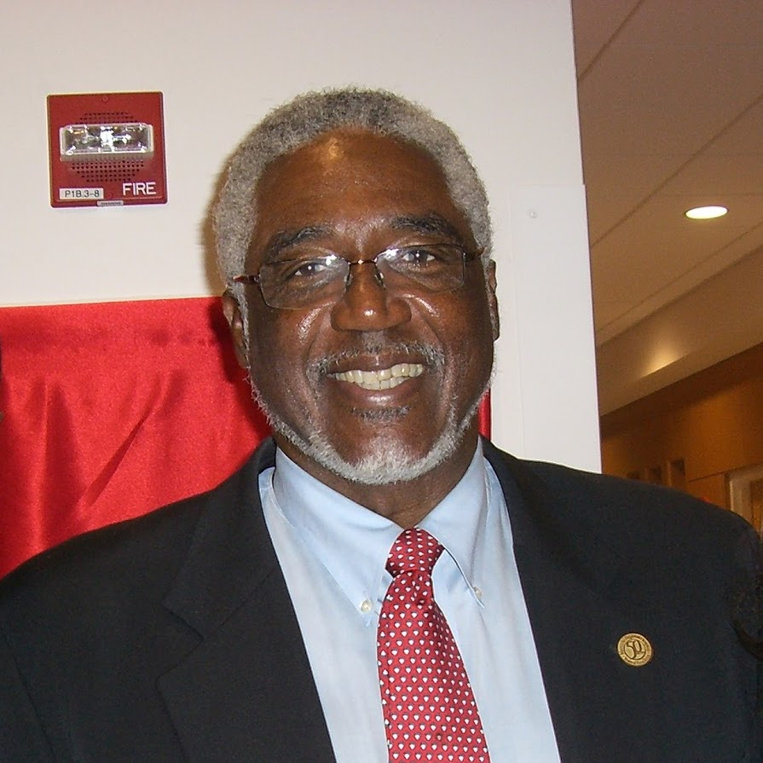
The strengths I bring are character, ability, responsibility and experience. My goals for the next term are to continue the efforts of economic development and also decrease the millage rate and expand the tax base. The LGBT Community should support my candidacy because whether on the dais or off, I have always represented the offices or positions held with dignity and integrity. Transparency and accountability is of the utmost importance to me and being a trusted servant leader demands just that! To whom much is given, much is required and as a believer in change for the past twenty-five years, I have the skills to bring our city to the next level.

By signing this questionnaire, you are stating that if selected you would accept the Dolphin Democrats public support and endorsement.

Signature: Albert C. Jones Date:9/5/16

